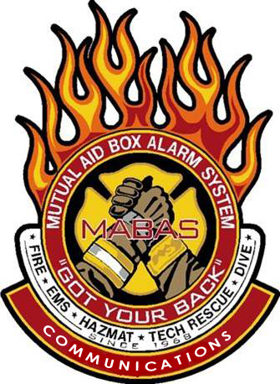

This seminar will take place at the

**EFFINGHAM EVENT CENTER**

**1501 W Fayette Avenue**

**Effingham, Il 62401**



**To register, email the *attendee name*, *agency* and *MABAS Division#,* and their *individual email address* to *tcd@redcenter.org***

Wednesday, April 23, 2025

The MABAS Communications Committee will be returning to ***Effingham***

with our regional Training Seminar program, where we will cover a wide variety of MABAS and Communications related topics!

***ALL First Responders*** are encouraged to attend to learn the critical role they play with MABAS!

To Register: Send Attendees name, direct email and Division affiliation to [tcd@mabas-il.org](mailto:tcd@mabas-il.org)

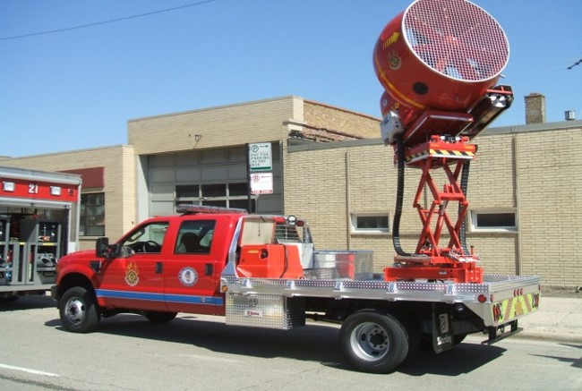 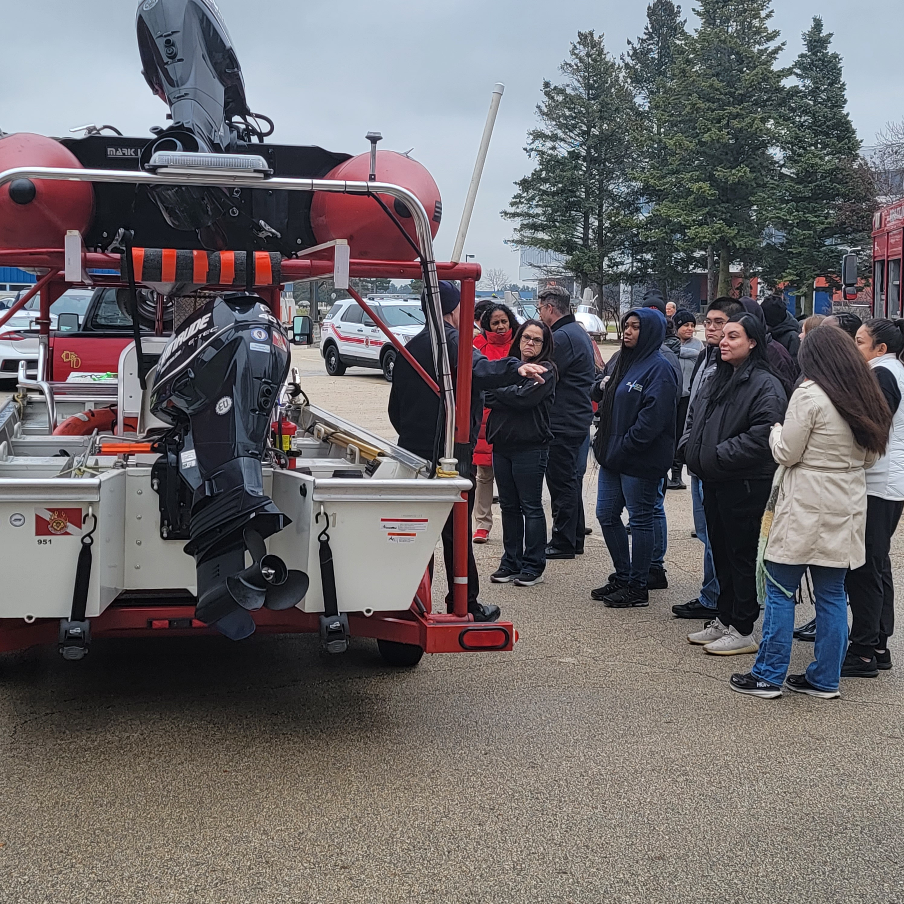

Attention ***ALL*** First Responders!

You are invited to attend a ***FREE MABAS Training Seminar!***

#### 

#### Time: 08:30-4:30 Lunch will be Provided

#### Class limited to 40 participants! Register early!

#### OVERTIME/BACKFILL reimbursement is available!



##### ***HIGHLIGHTS***

* MABAS overview
* History of MABAS
* Box Cards
* Deployments
* Box Alarm simulator
* An outside Resource display and more….